Ontario’s Sustainable Bait Management Strategy DRAFT
2019

Summary
The management of Ontario’s bait resources (i.e., baitfish and leeches) is challenging due to increasing environmental pressures such as invasive species and diseases that threaten the health of native fisheries and aquatic ecosystems. The harvest, movement and use of bait pose a significant risk to Ontario’s fisheries and biodiversity. The purpose of this strategic policy framework is to describe Ontario’s policy direction regarding the harvest, use and movement of bait by anglers and commercial operators. The proposed direction provided in this document is intended to reduce the ecological risks associated with the use and movement of bait and provide transparency and certainty for a sustainable bait industry that ensures the continued use of bait.

Resumé

Cette publication est egalement disponsible en francais

© Queen’s Printer for Ontario, 2019
Printed in Ontario, Canada

Fisheries Section, Species Conservation Policy Branch
Ontario Ministry of Natural Resources and Forestry
Peterborough, ON
300 Water Street
Peterborough, ON
K9J 8M5

ISBN #xxx (Print)
ISBM #xxx (PDF)

Table of Contents

1.0 Introduction 1
1.1 Purpose and Scope 1
1.2 Regulatory Context 2
2.0 Permitted Baitfish Species and Possession Limits 2
2.1 Permitted Baitfish Species 2
2.2 Possession Limits 3
3.0 Movement of Bait 4
3.1 Bait Management Zones 5
3.2 Exceptions to the Movement of Bait 6
3.3 Commercial Receipts and Documentation 8
3.4 Storage 8
4.0 Use of Bait in Native Brook Trout Lakes 9
5.0 Commercial Bait Operations 10
5.1 Training 10
5.2 Equipment 10
5.3 Reporting 11
5.4 Compliance 12
5.5 Commercial Bait Licences 12
5.5.1 Terms and Renewal 12
5.5.2 Allocation 12
5.5.3 Dormancy 14
6.0 Conclusion 14
7.0 Glossary 15
8.0 Legal References 17
Appendix A – Fisheries Management Zones (FMZ). 18

Introduction
Ontario’s fisheries resources contribute more than $2.2 billion dollars to the provincial economy and employ an estimated 41,000-person years annually. They provide wholesome food and recreation, are integral to the cultures and ways of life of Indigenous peoples, act as indicators of environmental quality, and contribute to the province’s economic, social, and environmental well-being. There are more than one million licensed anglers in the province of Ontario, and estimates indicate that 60 to 80 per cent of those anglers use live baitfish at some point during the year. The harvest and use of live baitfish have been an important part of the fishing industry in Ontario for nearly a century.
Ontario’s commercial bait industry, the largest in Canada, has a lengthy history, with approximately 1,100 commercial bait licences issued annually. The retail value of the bait industry is estimated at $23 million (2005) and additionally supports the multi-million-dollar fishing and tourism industries.
The management of Ontario’s bait resources is challenging. The use of bait is a vector for potential spread of fish-based diseases (e.g., viral hemorrhagic septicemia [VHS]) and invasive species (e.g., Round Goby) across Ontario. The bait pathway may also result in incidental movement of native species (e.g., Yellow Perch, Bass) to waters where they do not occur naturally. This can disrupt fish community dynamics in the receiving waterbody, including the loss of native species (e.g., Brook Trout).
Efforts to mitigate the risks of spreading invasive species and disease through the use and movement of bait is a shared responsibility amongst all of those involved in the bait pathway, including harvesters, dealers and anglers.
There are several ways that non-target species and diseases may be introduced through the harvest or use of bait:
- Illegal dumping of bait-bucket contents, which may contain incidentally harvested species, by anglers;
- Escape of incidentally captured non-target species from holding containers used by anglers or commercial operators;
- Transport of non-bait species (e.g., spiny water flea, Eurasian Milfoil) in holding water or on harvesting gear.

Purpose and Scope
The purpose of this strategic policy framework is to provide direction for the sustainable use and harvest of bait (i.e., baitfish and leeches) in Ontario. In this policy, ‘bait’ refers to both baitfish and leeches (live or dead). It does not include crayfish, frogs or worms.
The direction outlined in this policy balances the following four goals:
- To protect the health of aquatic ecosystems;
- To enhance the quality of life for Ontarians by providing recreational, social and economic benefits;
- To conserve the resource and maintain a viable bait industry; and
- To create policies that are adaptable, effective, consistent across the province, and simple to implement.
The direction outlined in this policy applies provincially, unless otherwise stated. Proposed direction adds to but does not eliminate existing bait use or harvest regulations for specified lakes and regions (e.g., existing prohibition against possession and use in Fisheries Management Zone (FMZ) 1, restrictions on commercial harvest in FMZ 9).

Regulatory Context
Ontario’s regulations governing the provincial management of bait are established under two key pieces of legislation; the federal Fisheries Act (implemented through the Ontario Fishery Regulations, 2007 [OFR]) and Ontario’s Fish and Wildlife Conservation Act, 1997 (FWCA). Provincial policies and guidelines provide operational direction in managing commercial bait licences. To implement the proposed direction in this document, new regulations or amendments to existing regulations would be proposed. These processes would take from one to three years to complete.
MNRF respects Aboriginal and treaty rights recognized and affirmed by Section 35 of the Constitution Act, 1982, and is committed to meeting its constitutional and other legal obligations in respect of Aboriginal peoples. The ministry will continue to work with First Nation and Métis communities to achieve mutual goals for bait management in Ontario

Permitted Baitfish Species and Possession Limits

Permitted Baitfish Species
There are over 165 fish species known to occur in Ontario. Many of these are native to Ontario, while others have been introduced. It can be challenging to distinguish some common bait species from sport fish, invasive fish or species at risk. Limiting the list of species that may be used as baitfish minimizes the risk of moving non-target species across the landscape.

The following lists the 34 fish species that could be used as bait in Ontario:
Minnows
- Blacknose Dace
- Blacknose Shiner
- Blackchin Shiner
- Bluntnose Minnow
- Brassy Minnow
- Central Stoneroller
- Common Shiner
- Creek Chub
- Emerald Shiner
- Fallfish
- Fathead Minnow
- Finescale Dace
- Golden Shiner
- Hornyhead Chub
- Lake Chub
- Longnose Dace
- Mimic Shiner
- Northern Redbelly Dace
- Pearl Dace
- Redfin Shiner
- River Chub
- Rosyface Shiner
- Sand Shiner
- Spotfin Shiner
- Spottail Shiner
- Striped Shiner

Suckers
- Longnose Sucker
- White Sucker

Sticklebacks
- Brook Stickleback
- Ninespine Stickleback

Other
- Banded Killifish
- Central Mudminnow
- Lake Herring
- Trout-Perch

By maintaining a wide range of eligible baitfish species, anglers and commercial operators would have the flexibility to use and possess locally common species. Certain fish species such as sculpins and darters would not be included on the list as they are often confused with invasive species (e.g., Round Goby) and they are typically not desirable or valuable species for anglers and operators. Banded Killifish would be added to the list because it is relatively abundant and ubiquitous throughout the lower Great Lakes.
Permitted baitfish species are regulated under the OFR and amendments are required to update the list.

Possession Limits
Possession limits help to ensure the sustainable use of the resource. The following possession limits would continue to apply:
Anglers may only possess up to 120 baitfish and 120 leeches.
These limits, apply to both purchased and personally-harvested bait (live or dead), are in place to address concerns related to bait wastage.
Commercial bait licence holders are not restricted in the amount of bait that they can possess.
With limited exceptions, commercial bait harvesters and dealers are not restricted in the amount of bait they can harvest or possess for sale. This flexibility allows operators to possess enough bait to supply their customers’ needs and to effectively run and operate their businesses. Harvesters are responsible for the sustainable management of the bait in their BHAs.
These possession limits are regulated under the OFR and the FWCA.

Movement of Bait
The spread of invasive, non-target species and diseases may be facilitated through the movement of bait. Dumping the contents of bait buckets (including the water holding the bait) in or within 30m of a watercourse is illegal. Despite this, studies have shown that a considerable number of anglers continue to dump their bait into the waterbody they are fishing. This activity risks spreading non-target species and disease.

Many anglers harvest their own bait: surveys have shown that 30 to 50 per cent of Ontario anglers who fish with live baitfish harvest their own bait at least some time during the year. It has also been shown that, in general, anglers in Ontario experience great difficulty distinguishing legal baitfish species from illegal species. Consequently, personally harvested bait brings an increased risk of moving invasive and other non-target species across the landscape.

An estimated 4.2 million angling trips involving live bait take place each year in Ontario, where approximately 25% of these trips occur over distances greater than 400km. A large portion of Ontario anglers live and purchase bait in the southern part of the province, where invasive species and diseases are most prevalent. This large-scale movement of bait increases the risk of spreading species and diseases to new parts of the province.

Consequently, controlling the movement of bait from the point of harvest to where it is ultimately used is a critical component of managing the ecological risks. A zonal approach is proposed to reduce the risk of spreading species and diseases while providing increased business certainty to the bait industry across Ontario, allowing commercial operators to make the necessary adjustments and investments to grow and maintain their businesses.

Bait Management Zones
To address the risks associated with the movement of bait, the following direction is proposed:
The movement of bait, including commercial bait, angler purchased bait and personally harvested bait, whether dead or alive, would be limited to the four Bait Management Zones (BMZs) shown in figure 1.

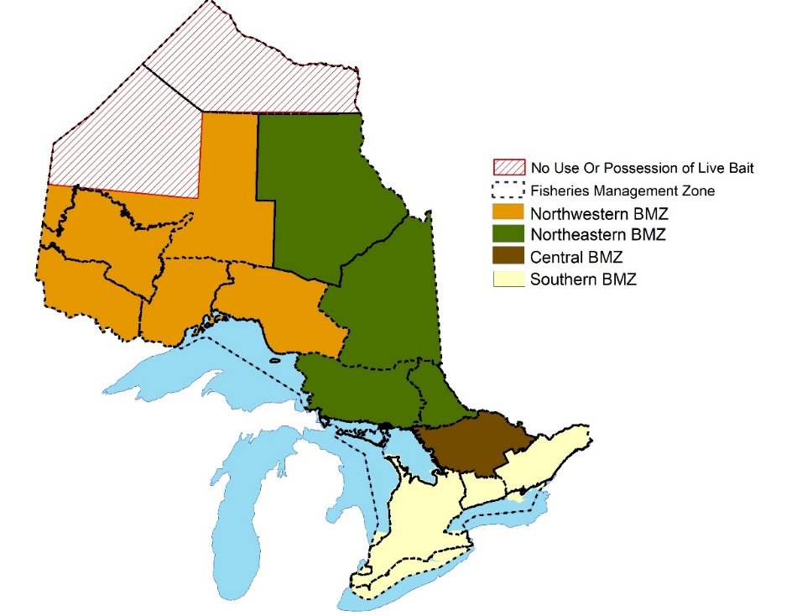

Figure 1 – Bait management zones (BMZ) depicting boundaries of bait movement.
BMZs are defined regions within which anglers and commercial operators may move their bait. Anglers and commercial operators would only be allowed to move their bait within the zone where the bait was harvested, with a few exceptions identified in section 3.2. Commercial operators would not be allowed to have their bait tested to facilitate movement out of the BMZ where the bait was harvested.
The Great Lakes would not be included within the BMZ framework (figure 1) as most of the Great Lakes do not have designated Bait Harvest Areas (BHAs). A few exceptions exist in Lake Erie and in defined areas of Lake Huron and Lake Ontario. In these locations, commercial bait (but not personally harvested bait) could move inland to the adjacent Southern BMZ. Bait would be able to move into these Great Lakes as per the exceptions in section 3.2.
The BMZ boundaries are based on the established provincial Fisheries Management Zone (FMZ) framework (Appendix A); in most cases, a few FMZs would be amalgamated to form a single BMZ. Using the FMZ boundaries as the framework for the BMZs ensures that the boundaries are easily identifiable on the ground (unlike watershed divides), are already established in regulations, and are familiar to anglers.
Upon implementation of the BMZs, existing restrictions to commercial bait movement (i.e., VHS and Lake Simcoe Management Zones) would no longer apply.
MNRF would pursue regulatory amendments to the OFR and the FWCA to implement the BMZs, including the exceptions outlined in section 3.2.

Exceptions to the Movement of Bait
Bait movement would be limited to each BMZ, with the following exceptions:
Bait from the Northwestern, Northeastern, Central and Southern BMZs would be allowed within the adjacent Great Lake(s), as shown in figure 2.

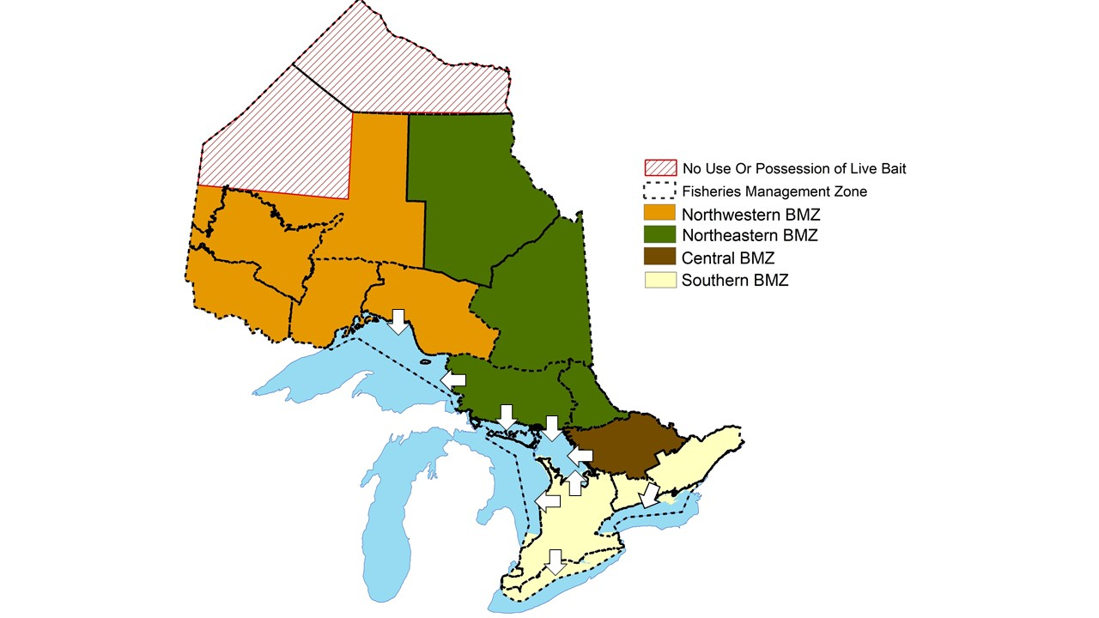
Figure 2 – Bait management zones showing exception (white arrows) for movement of bait out of BMZs into the Great Lakes.
In general, the lower Great Lakes (i.e., Lakes Erie and Ontario) have a much higher prevalence of aquatic invasive species and disease than inland sources. Given that lakes and rivers flow downstream from inland sources into the Great Lakes, organisms and pathogens that occur inland are typically found in the Great Lakes as well. Therefore, there is minimal ecological risk associated with the movement of bait from inland BMZs into an adjacent Great Lake. It should be noted that bait could not be transported overland through another BMZ for use in a Great Lake (e.g. bait could be moved from the Northeastern BMZ into Georgian Bay, but not south overland into Lake Ontario).
Islands that are located within the Great Lakes, including Manitoulin Island and St. Joseph Island, would be considered part of the Great Lakes (i.e., bait from adjacent inland BMZs may be moved onto the island for use but could not be moved off the island). A few limited exceptions may apply.
Bait from the Southern, Central and Northeastern BMZs would be allowed in the Ottawa River (including Lake Timiskaming) (figure 3); however, bait could not be moved across another inland BMZ to reach the Ottawa River. Commercial bait harvested in the Ottawa River would have to remain in the adjacent BMZ.
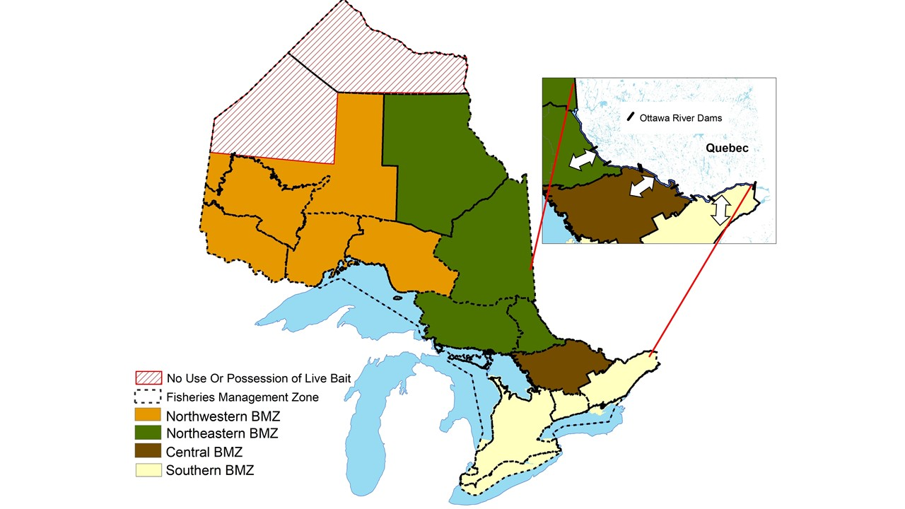
Figure 3 – Bait management zones showing exception (white arrows) for movement of bait in and out of the Ottawa River.
In Ontario, the Ottawa River extends from the St. Lawrence River to Lake Timiskaming. Due to its proximity to the St. Lawrence River, the southern reaches of the Ottawa River have a higher likelihood of containing invasive species and diseases. The river is fragmented by nine large impassable barriers (some of these falling close to the BMZ boundaries) that considerably limit the movement of fish (and anglers) between reaches, thereby reducing the risk of species spread. As a result, anglers using live bait in each section of the Ottawa River could use bait that originates from the BMZ where they accessed the river. Commercial operators that have Bait Harvest Areas (BHAs) within the Ottawa River would be allowed to move their bait inland into the adjacent BMZ for distribution (similar to the exception provided for commercial harvesters with BHAs in the Great Lakes).

Commercial Receipts and Documentation
The following direction is designed to ensure compliance with the prescribed bait movement zones for both commercial (purchased) and personally harvested bait.
Anglers in possession of bait (either purchased or personally harvested) within the BMZ of their primary residence (as indicated on their fishing licence or other valid form of government issued identification) would not be required to retain a receipt or other documentation.
Anglers in possession of bait outside of the BMZ of their primary residence would be required to purchase the bait in the BMZ they are using it in.
Anglers would be required to retain the receipt in their possession to demonstrate that the bait was purchased in the appropriate BMZ within the previous two weeks.
Anglers would be required to use or lawfully dispose of all commercially harvested bait within two weeks of purchase. The two-week expiration would ensure that anglers are in compliance with BMZ purchase requirements.
Bait that is personally harvested from the Great Lakes and the Ottawa River (including Lake Timiskaming) could not be transported inland.
All commercial bait transactions (e.g., from licensee to licensee), would need to be accompanied by a receipt that clearly states the name of the seller/business, location, and date of where and when the bait was sold.
MNRF would pursue regulatory amendments under the FWCA to implement this policy.

Storage
Both anglers and commercial operators commonly store their bait in waterbodies. Anglers often store their bait in a bait bucket that is tied to a boat, dock or to the shoreline, whereas commercial operators frequently use large cribs for storage. The water used to transport the fish is typically transferred into the bait bucket or crib and can end up in the receiving waterbody. This water may contain microscopic plants and organisms, some of which may be invasive. While emptying the contents of a bait container (including the water within) directly into a waterbody is illegal, many anglers continue to do so. The in-water storage of commercial bait is also considered a high-risk activity because large volumes of bait have the potential to escape from the holding container.
Provincially, the storage of bait, including but not limited to bait buckets and cribs, would need to be consistent with the applicable scale of movement, as outlined below:
Bait from all four BMZs (both commercial and personally harvested) would need to be stored in the same BMZ where it was purchased or harvested, or be stored consistent with the identified movement exceptions in section 3.2
Additional advice pertaining to the storage of commercial bait would be provided in future best management practice documents (see section 5.2).

Use of Bait in Native Brook Trout Lakes
Brook Trout, a desirable sport fish in Ontario, are sensitive to changes in their fish communities and generally only occur where there are a few other fish species present. When new species such as an invasive species (e.g., Round Goby) or species native to other parts of Ontario (e.g., Yellow Perch, Smallmouth Bass) become established in a Brook Trout lake, it can have devastating consequences on the resident Brook Trout population. Evidence from provincial monitoring programs shows that native Brook Trout populations in lakes across Ontario are being lost, and that many of these losses can be attributed to the introduction of new species. To protect native populations of Brook Trout, the following direction is proposed:
The use and storage of bait would be prohibited in native Brook Trout lakes.
This direction is not intended for lakes that are actively stocked (e.g., Put-Grow-Take fisheries) or lakes where Brook Trout no longer occur. This policy would help to achieve consistent direction across the province as it relates to Brook Trout, though additional direction may be identified through FMZ planning processes. To identify which lakes this would apply to, the MNRF would develop a list of lakes that would be considered ‘native’ for this policy. This direction would not apply to Lake Superior or rivers and streams with Brook Trout.
MNRF would pursue regulatory amendments both to the OFR and the FWCA to implement the proposed changes to the use of bait in native Brook Trout lakes.

Commercial Bait Operations
The following direction pertains to licensed commercial bait harvesters and dealers.

Training
Commercial bait operators play a pivotal role in helping to minimize the transfer of non-target species and pathogens. Numerous individuals are involved in the commercial movement of bait from the point of harvest to the ultimate place of sale including harvesters, designates, wholesalers and dealers; all of whom are responsible for ensuring that non-target bait species are not spread through the bait pathway.
The following would increase industry’s awareness of the potential risks of moving non-target species and actions that can be taken to prevent their spread.
Commercial bait harvesters and dealers would be required to take a standardized training course, to be administered by the MNRF.
The purpose of this training course would be to increase harvester and dealer awareness of non-target species, including invasive species and species at risk, and identify actions to prevent their spread.
In addition to harvesters and dealers, designates listed under a commercial harvester’s licence would be required to take a training course (to be developed by the MNRF). Designates would be required to take the training prior to being added to a licence.
Designates listed on a licence can harvest bait on the licensee’s behalf and should therefore be trained about the potential risks of spreading non-target species. The licence-holder would still be required to ensure that everyone involved in their operation is aware of their licence conditions, as well as the rules and regulations that apply to the sale and harvest of bait.

Equipment
The MNRF limits the type of commercial equipment allowed, the length/size of mesh, number of traps, and other types of commercial gear to help prevent threats to the resource (e.g., overharvest, escapement from storage). Currently, gear restrictions are identified through licence conditions. Conditions vary by licence across the province, and even among licences in multi-use BHAs. Licence conditions lack standardized gear conditions and are therefore very complex, difficult to administer, and vary in their ability to protect the resource.
The following would generally apply to commercial gear:
In multi-use BHAs, the amount and type of gear allowed would be standardized among all licensees.
The MNRF would work with commercial bait operators to develop a Best Management Practices (BMP) Guide for bait harvesting and storage.
The BMP guide would be developed in collaboration with representatives from the bait industry to be used to educate harvesters and promote the use of standardized, industry-supported methods in bait harvest operations. The BMP would address topics related to gear types, appropriate mesh sizes, storage locations, and methods to minimize impacts on species at risk and their habitats (as outlined in Section 5.3).
In multi-use BHAs, equipment and limitations on gear would be implemented through conditions on the harvester’s commercial bait licence.

Reporting
Record keeping and reporting by commercial operators is a tool used by the MNRF to effectively manage the bait resource. The MNRF requires annual reports to be submitted which outline the amount of bait harvested in a BHA and the amount of bait sold to anglers. This is done to understand the level of harvest, industry dynamics and the value of the industry. Logbooks are also a business record for operators and can be used by conservation officers for compliance purposes.
The current reporting structure, however, does not allow tracking of bait from the point of harvest to the place of sale. This limits the MNRF’s ability to promote compliance. The following is intended to increase the effectiveness and transparency of reporting requirements:
Using MNRF-prescribed logbooks, all commercial bait licence holders would be required to document bait transactions between licence holders, including when the transfer occurred, the quantity of bait transferred and to/from whom bait is purchased/received and sold.
In combination with the mandatory issuance or receipts, more effective reporting (i.e., recording all transactions) will allow for increased transparency and accountability.
Commercial bait harvesters would continue to be required to document (in their logbooks) the date and amount of bait harvested in a specific BHA. Commercial bait licence holders would continue to be required to complete an Annual Report for Commercial Bait Harvesting or Dealing that documents the amount of bait harvested or sold at the retail level (to the angler).
The requirement to keep a logbook in a form required by the Minister is set out in a regulation under the FWCA.

Compliance
Non-compliance for commercial bait operators includes a range of possible infractions, including a breach of licence conditions, or violations of regulations under the Fish and Wildlife Conservation Act, 1997 and the Fisheries Act (Ontario Fishery Regulations, 2007). Generally, non-compliance includes operational violations (e.g., the possession of non-bait species) and administrative violations (e.g., failure to properly complete daily logbooks). In some cases, the MNRF has the authority to revoke, amend or refuse to issue a licence; however, there are currently no clear criteria for taking such action. To address this:
The MNRF would work with industry representatives to develop a policy outlining a compliance framework that describes when MNRF should evoke, suspend or reissue a commercial bait licence.
The implementation of a compliance framework would be established in an operational policy.

Commercial Bait Licences

Terms and Renewal
Any individual who harvests or sells bait is required to have a commercial bait licence. These licences are administered by the MNRF and are currently renewed annually. To increase flexibility for licensees:
Commercial bait licences may be renewed for a period of up to three years.
Changes to commercial bait licences would be established in operational policies.

Allocation
Since the 1960s, the bait resource in Ontario has been allocated to licensed harvesters based on Bait Harvest Areas (BHAs). BHAs vary in size and configuration, and typically allow exclusive harvesting rights within an area to a single licensee. In some cases, where there are high densities of bait (e.g., Lake Simcoe, Lake Erie), BHAs may be allocated to multiple harvesters with different licences. In some BHAs, leeches and baitfish are also allocated separately to different licensees.
To reduce resource conflicts between harvesters and to simplify licence administration, the following policy would apply:
The provincial bait resource would continue to be allocated based on the existing BHA system.
With the exception of BHAs with high bait densities which would remain multi-use, all other BHAs would be exclusive-use allocations, regardless of the type of bait being harvested (i.e., baitfish and/or leeches).
With this approach, BHAs would not be allocated to a separate baitfish harvester and a leech harvester. In situations where multi-use BHAs are to revert to exclusive use, allocations would continue until one of the BHA harvesters is no longer interested in harvesting (i.e., transfer of the BHA would not be allowed).
Any BHA that is intersected by a BMZ would be split along the established BMZ boundary into two new BHAs.
The new subdivided BHAs would continue to be allocated to the initial BHA holder. A single BHA fee would be applied to these two new BHAs until either one of the BHAs is not allocated or is transferred to another harvester.
Licensed harvesters would continue to be allowed to transfer BHAs to other licensed harvesters, subject to MNRF approval.
The transfer of BHAs between harvesters may be extremely useful to allow operators to adjust their businesses to adapt to the changes described in this policy.
When a BHA becomes available for allocation and multiple harvesters have expressed an interest in acquiring it, the BHA would be re-allocated based upon a revised point system. This revised point system could incorporate the following:
- Increased opportunities for Indigenous people within their traditional territories;
- Increased weighting for harvesters who have adjacent BHAs;
- Increased weighting for new harvesters who can demonstrate a sound business plan;
- Decreased weighting for harvesters who have been convicted with bait-related offences.
- Consideration may be given to existing harvesters who may have been adversely affected by the new regulations.
A point system has been in place since 2001 to allocate bait resources in a fair, objective and transparent manner; however, the point system is heavily weighted to existing harvesters with numerous BHAs, making it difficult for others to enter the industry.

Dormancy
Bait Harvest Areas are allocated by the MNRF with the expectation that they will be harvested by the licensee. In some years, harvesters may reasonably choose to leave some BHAs dormant to replenish stocks, while others may not intend to continue harvesting. To reduce issues of bait shortages within a BMZ, it is important that BHAs are continually and sustainably harvested to supply demands.
If a BHA remains dormant (i.e., unharvested) for a period of five years, MNRF would make that BHA available for re-allocation under another licence.
A dormant BHA would be defined by ‘not reasonably contributing to the overall harvest of bait either on an annual basis or at some point over a five-year period’. Since many harvesters choose to rotate their BHAs on a four-to-five-year cycle to increase the standing crop of fish, five years is chosen as an acceptable dormancy period. Exceptional circumstances may be considered.

Conclusion
The harvest and use of live baitfish have been an important part of Ontario’s fishing industry for nearly a century, with the majority of anglers using live bait at some point during the year. The harvest, use and movement of bait comes with ecological risks and the historical bait management framework has been perceived as reactionary, overly complex to administer, and relatively poor at mitigating risks.
The policies outlined in this document were developed to protect the health of aquatic ecosystems by reducing the ecological risks associated with the harvest, use, and movement of bait, while maintaining a viable bait industry and providing business certainty for the industry. It is the MNRF’s intention that the direction provided within this policy will help to ensure the sustainable use and harvest of Ontario’s bait resource while reducing the complexity of the bait management regime. Education and awareness of the risks of invasive species, disease and the movement of non-native species is critical to help ensure the effectiveness of these policies. As such, MNRF will continue to work with and provide outreach to anglers, stakeholder, the public, industry and Indigenous communities.

Glossary
The terms that follow are defined as used in this policy.
Bait: live or dead baitfish and leeches; not crayfish, frogs or worms.
Bait Harvest Area (BHA): a defined area identified on a commercial bait licence where the holder is authorized to harvest bait within the province of Ontario. Bait Harvest Areas can be either ‘exclusive-use’, where an area has been allocated on a single licence, or ‘multi-use’, where the area has been allocated on more than one licence.
Bait Pathway: the collective movement of bait from the point of harvest through retail operations to the sale to the angler and its subsequent use.
Commercial Bait: bait that is harvested and/or sold by a commercial bait licence holder; includes bait purchased by an angler.
Dealer: an individual licensed to sell commercial bait.
Ecological risk: actual or potential threat of adverse effects on the environment, including but not limited to a species, a habitat, or an ecosystem.
Existing licensee: an existing commercial bait harvester with a licence for a bait harvest area containing all or portions of a wilderness, nature reserve, natural environment, waterway and/or cultural heritage class park as of the time this policy is approved.
Great Lakes: in reference to the Canadian portion of the Laurentian Great Lakes, including Lake Superior, Lake Huron, Lake Erie and Lake Ontario and their connected waterways, such as the St. Mary’s River, St. Clair River, Lake St. Clair, the Detroit River, the Niagara River and the St. Lawrence River.
Harvester: an individual licensed to collect (harvest) bait within designated Bait Harvest Areas for the purpose of selling it.
Invasive Species: alien species, including those species that are native to Ontario but have been introduced to a new geographic region due to human activity, whose introduction or spread threatens the environment, economy, and/or society including human health.
Non-target species: a species of fish that is not a legal baitfish in the province of Ontario.

Put-Grow-Take fishery: a fishery that stocks sub-catchable-sized fish (e.g., fingerlings, yearlings) with the intent that they will grow and ultimately provide angling opportunities.
Storage: the retention of bait in holding devices by commercial or personal bait harvesters. Often, bait storage takes place in holding devices within a waterbody.

Legal References

Fish and Wildlife Conservation Act, 1997
Fisheries Act, 2016
Ontario Fishery Regulations, 2007
Ontario Regulation 664/98 - Fish Licensing

Appendix A – Fisheries Management Zones (FMZ).

